The Fifth Nanak
Guru Arjan Sahib Ji

September 1, 2019

by
dedicated Sewadars
of
Sri Hemkunt Foundation Inc.

INDEX

# | Title | Page
1 | Education and Early Life | 2
2 | A Lesson in Obedience | 4
3 | Arjan Sahib ji becomes the Fifth Nanak | 5
4 | Swayye recited by Bards (Bhatt) | 7
5 | Pride & Greed of Satta & Balwand | 8
6 | Harmandar Sahib | 10
7 | Marriage | 13
8 | Bhai Manjh | 14
9 | Merely reading Holy Books does not help | 16
10 | Treat Diseases with Medicine | 17
11 | Popularity of Sikh Gurus | 18
12 | Adi Granth Sahib | 20
13 | Jahangir Arrests Guru Arjan | 23
14 | Martyrdom | 25
15 | Highlights of The Fifth Nanak | 27
16 | World Events (1563 - 1607) | 28
17 | References | 28

- Education and Early Life

1563 AD: The fifth Guru of the Sikhs, (Guru) Arjan Sahib ji was born on April 15, 1563 AD in village Goindwal, Amritsar. He was the youngest of three children of the fourth Nanak, Sri Guru Ramdas ji and mother - Bibi Bhaani ji. (at this time Guru Ramdas ji’s name was Bhai Jetha as he had not assumed the responsibility as the Guru). Bibi Bhaani ji was the younger daughter of the third Nanak - Sri Guru Amardas ji. She is the only woman in Sikh history to have the honor of being a Guru’s daughter, a Guru’s wife and a Guru’s mother. (Guru) Ramdas ji and Bibi Bhaani ji served at Guru’s institution after their marriage and lived at Goindwal. Arjan Dev⁽¹⁾ ji received love and care from his grandfather and also learned to recite sacred hymns.

Arjan Dev ji grew up in the company of his maternal grandfather - the third Nanak (Guru Amardas ji) since his birth. His two elder brothers - Baba Prithi Chand and Baba Mahadev also grew up in the company of the third Nanak. However, the third Nanak had a special affinity for the youngest grandson - Arjan Dev. Arjan Dev ji was fortunate to spend first 11 ½ years of his life in the company of the third Nanak and received spiritual education during early formative years. This time is long enough for a child to develop his/her own personality and develop interest in certain aspects of life. In his case, it was Gurbani.
Guru Amardas ji paid great attention to Arjan Dev’s education. Arjan Dev ji learned Gurmukhi script from Baba Budha ji. His uncle, Mohri imparted knowledge of Arithmetic. The village Priest taught him Devnagri (Hindi script). A Muslim Priest taught him Persian and Pandit Beni taught him Sanskrit. Arjan Dev became an expert in music. He composed hymns in accordance with Raags (musical notes). He classified the hymns of Guru Granth Sahib according to the Raags. He was an excellent horse-rider and archer as well.

1574 AD (age 11): Arjan Dev ji’s father - Sri Ramdas ji was bestowed Guruship and became fourth Nanak. Third Nanak (Guru Amardas) passed away on September 1.
________________________________________________________________________
- The Fifth Nanak was known as Arjan Dev before becoming the Guru and Arjan Sahib afterwards.
************************

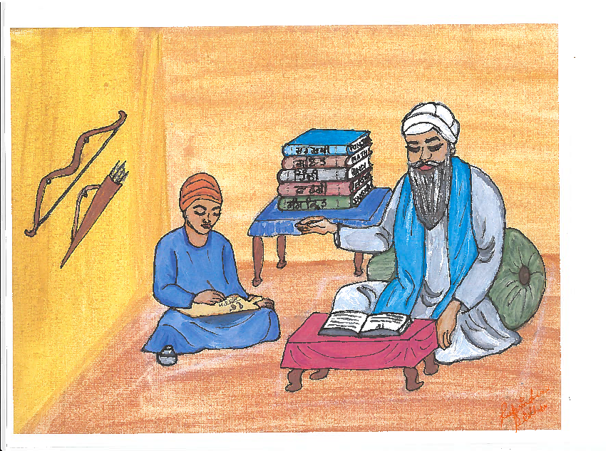

2. A Lesson in Obedience

1581 (age 18): Guru Ramdas ji’s cousin, Sihari Mal came to invite Guru ji to Lahore for his son’s marriage. At the time, Guru Ramdas ji was busy with the construction of the city of Amritsar, and thought of sending one of his sons, instead, to attend the marriage. He asked his eldest son - Prithi Chand to go. Prithi Chand sensed that the time for Guru Ramdas ji to joti jot smaey was getting near. Prithi Chand was afraid that he might be deprived of the succession to the leadership of the Sikhs if he was away at Lahore at that time. Therefore, he declined stating that he managed the offerings from devotees, and this would suffer if he was away.

After getting negative response of Prithi Chand, Guru Ramdas ji asked his second son - Mahadev, who was of saintly nature. He also declined stating that he had nothing to do with the customs and rituals of this world and had no interest in attending the marriage. On hearing the refusal of two sons, Guru Ramdas ji asked the third son - Arjan Dev who was 18 years old at that time- if he would go to Lahore. Arjan Dev ji respectfully accepted Guru ji’s instructions to go to Lahore. Guru Ramdas ji instructed Arjan Dev to remain in Lahore until he is asked to return.

As instructed by his father, Arjan Dev ji stayed and started holding daily congregation for public, once the marriage was over. Arjan Dev ji would meet with holy men including Saint Mian Mir and exchange his views with them. After waiting for several months, Arjan Dev ji wrote to Guru Ramdas ji allowing him to return. Prithi Chand intercepted the letter but did not give it to Guru Ramdas ji to ensure that Arjan Dev ji is not called back. Arjan Dev ji wrote a second letter. This too was intercepted by Prithi Chand. Arjan Dev ji sent a third letter through a Sikh and instructed him to hand it over to Guru ji only and no one else. When Guru ji got the third letter, he asked Prithi Chand for the previous two letters, but he denied receiving any letters. Prithi Chand’s house was searched, and both the letters were recovered. Guru Ramdas ji immediately sent Sikhs to Lahore to bring back Arjan Dev ji.
************************

3. Arjan Dev ji becomes the Fifth Nanak

1581 (age 18): Upon Arjan Dev ji’s return from Lahore, Guru Ramdas ji felt his time to depart from the world was coming near. He concluded that his youngest son, Arjan Dev, alone was fit for the Guruship. He made his decision known to his followers and they agreed with him. Then he called a meeting with his principal Sikhs where he came down from his seat. He seated Arjan Dev ji on it in the presence of the entire assembly. He then bowed before Arjan Dev ji and pronounced him the fifth Nanak. This happened on August 28, 1581. All assembled Sikhs bowed to the fifth Nanak as instructed by the fourth Nanak (Guru Ramdas ji). Fourth Nanak presented the holy book containing hymns recited and recorded by him, the previous three Nanaks as well as those of Saints (Bhagats) and holy men.

Prithi Chand thought that being the eldest son, it was his right to become the Guru after his father. But his father had given the Guruship to Arjan Sahib - the youngest son. Prithi Chand got angry. He spoke to Guru Ramdas in harsh & angry words. He accused his father for denying him his right to become Guru and favoring the youngest son. He threatened to remove him and declare himself the Guru.

Ramdas ji advised Prithi Chand not to quarrel with him and advised him to accept his decision like a good son. But Prithi Chand continued to speak in harsh language, threatened to drive Arjan Sahib away and become the Guru in his place.

The following day, Ramdas ji set out for Goindwal. He took Guru Arjan Sahib⁽²⁾ with him. There he bade farewell to his dear ones, departed from this world. This happened on September 1, 1581.

Guru Arjan Sahib ji returned to Guru-ka-Chak (presently known as Amritsar). There he began to carry out his duties as the fifth Guru of the Sikhs.

Prithi Chand went rogue and declared himself to be the new Guru. He dispatched his men all over to announce that he was the Guru. Many innocent Sikhs were deceived by his men. When the Sikhs came to Amritsar with their offerings, Prithia’s men directed them to him. Thus, all offerings went to Prithi Chand. Guru Arjan Sahib ji was left with no income. Still he managed to run the community kitchen (langar) with whatever little he had. He remained calm and busy in reciting God’s name. He took no steps against Prithi Chand. Guru Arjan Sahib Ji had full faith in God. He believed that truth would inevitably prevail.

Prithi Chand played another trick. While he took offerings from visiting Sikhs, he sent them to Guru Arjan Sahib ji’s langar for food. Guru ji did not object. All were provided with the best possible food they could arrange. He and his wife often had to live on minimal food. Sometimes it was just a small quantity of coarse food, only once a day, yet they were very content.

This went on for some time. One day Bhai Gurdas ji came from Agra. He was a cousin of Bibi Bhani ji, Guru Arjan Sahib’s mother. He was wise and learned. He was heartbroken to see poor quality of food taken by the Guru ji and his wife and was sad to see what was happening.

Bhai Gurdas ji made up his mind to correct the wrongdoings. He met with leading Sikhs like Baba Budha ji and discussed the matter with them. Baba Budha ji met with visiting Sikhs at a place called Pipli Sahib. He explained to them about the tricks being played by Prithi Chand and his cohorts. Prominent Sikhs went out in all directions to inform the Sikhs of what was happening at Amritsar. Sikhs perceived the truth and resumed offerings to Guru ji. The Guru's langar became plenteous once again. Soon, the truth about the true guru, Guru Arjan Sahib ji spread all over.
_____________________________________________________________________________________________________________________________
(2) - The Fifth Nanak was known as Arjan Dev before becoming the Guru and Arjan Sahib afterwards.
************************

4. Sawayye recited by Bards (Bhatts)
1581 AD (age 18): Some bards were visiting holy places for pilgrimage in search of spiritual bliss. They had been visiting places for over a year but did not get the peace of mind they were seeking. Fortunately, they met a group of Sikhs going to Goindwal and decided to accompany them.

Bards were in search of a true Guru. Their concept of a Guru was an old person with grey hair. Upon meeting the fifth Nanak, who was only 18 years of age, they had their doubts. But after a conversation with Guru ji, they were impressed and convinced of Guru ji’s saintly nature and greatness. They also learned of Prithi Chand’s opposition to Guru ji. All the 11 bards were poets. They got inspiration to praise Guru ji and all four previous Nanaks and composed and recited Sawayyas in the praise of all five Nanaks.

Guru Arjan Sahib ji collected Sawayyas from Bards and arranged them with other hymns he had been bestowed by the fourth Nanak. Later, he himself composed 20 Sawayye and all these were included in the Adi Granth.

************************

5. Pride & Greed of Satta and Balwand

1582 AD (age 19): Satta and Balwand, father and son duo, were musicians at the Guru's institution. They made their living by singing hymns (Keertan) in Guru ji’s court (Dewan). While Prithi Chand had cunningly diverted offerings from Sikhs to himself and funds were not available to run the Langar, Satta arranged marriage of his daughter⁽³⁾. He requested Guru ji for financial help. Ignoring the financial circumstances, Satta asked for a large sum of money. Guru ji could not afford the requested amount which upset Satta greatly.

Prithi Chand used this incident to incite Satta and Balwand against Guru ji. Prithi Chand convinced them that devotees come to listen to their recitation. If they stop recitals, the devotees will stop going to Guru ji. Guru ji gets offerings only because of their talent.

Satta and Balwand could not sense that Prithi Chand was using them to harm Guru ji. Accepting Prithi Chand's suggestion, they did not go to Guru's institution the next morning for recital. Guru ji sent Sikhs to their house to fetch them for recital. Not only did they refuse but also used derogatory words about Guru's institution. Guru ji personally went to get them. They still refused and made insulting remarks for Guru’s institutions. Soon they started making derogatory remarks against Guru Nanak Dev ji. They said that Nanak Dev got famous only because their elder (Bhai Mardana) used to sing melodious hymns otherwise no one would have known Nanak. Guru ji could not tolerate this insult.

Guru ji suggested Sikhs to sing the hymns themselves. Guru ji himself was well versed in various Raags. He helped Sikhs to sing the hymns and further instructed Sikhs not to listen to recitals by Satta & Balwand.

Satta & Balwand were expecting that Sikhs would keep coming to them to listen to the Keertan. Naturally, they would get the offerings and would make a lot of money. But this did not happen as no Sikh came. Gradually, Satta & Balwand ran out of money and found it hard to put bread on the table. When financial situation became intolerable, they went to a famous Sikh in Lahore - Bhai Ladha - who was known to help anyone in need. Bhai Ladha accompanied Satta & Balwand to Guru ji to seek forgiveness.

Guru is always ready to pardon anyone if he/she is sincere and truly repents for the mistake. Guru ji forgave Satta & Balwand as they were really sorry for insulting Gurus. Upon learning that Guru ji has accepted them, they composed and sang a Vaar of eight Pauris in the praise of Gurus. First three Pauris are by Balwand and next five by Satta. The ill episode had happened because of dire financial conditions caused by Baba Prithi Chand. Hence, in these Pauris, Satta & Balwand described the Langar of Waheguru’s Naam run by Guru ji.

Guru ji included this Vaar as 'Satta ate Balwand Di Vaar' in Raag Ramkali in Guru Granth Sahib ji. It is on pages 966 to 968.
_____________________________________________________________________________________________________________________________
(3) - Some authors believe that this story is not correct. This has been made up just as some other stories connected with other Shabads in SGGS. They feel that Satta & Balwand wrote the Vaar just as other Bhatts (Bards) and Bhagats (Saints) composed praises for Gurus and Waheguru.
************************

6. Harmandar Sahib

1588 (age 25): The fourth Nanak (Guru Ramdas ji) envisioned, planned and started construction of a new town named Guru-ka-Chak (presently known as Amritsar). The fourth Nanak encouraged traders and businessmen to settle in the city with the development of the Guru Ka Bazaar and the market at Chowk Passian. Soon, the population of the new town started increasing. The fourth Nanak planned a Sarovar and a Gurdwara inside the Sarovar. It was a huge project requiring tremendous resources - both financial and material. The fourth Nanak started construction of the Sarovar. Before the construction was complete, Sri Arjan Sahib ji became the fifth Nanak.
The fourth Nanak introduced the concept of representatives (Masands) to collect offerings from Sikhs who were living too far from Guru ji. The collection would help the huge project. The fifth Nanak modified it to ten percent (Dasvand) for the Sikhs. Gradually, the message of Sikhi was spreading far and beyond. Funds collected by representatives (Masands) helped in the completion of the project.
Fifth Nanak resumed the construction of the holy Sarovar and called it “Amrit Sar”. It was completed in 1588. The Fourth Nanak had started it in 1570.

The foundation stone of the historic building inside the Sarovar as planned by the Fourth Nanak was laid by a non-Sikh in October 1588. It was named “Harmandar”. Foundation stone was laid by a Muslim Saint - Hazrat Mian Mir⁽⁴⁾ of Lahore. Mian Mir was a person with religious tolerance and respect for every human being. Fifth Nanak chose Hazrat Mian Mir to give true message of religion to the world - promoting interfaith dialogue and treating every human being with respect. Harmandar Sahib has four doors, one in each direction - North, East, South & West. It signifies that men/women from any direction and any caste can enter the house of God.
Construction of Harmandar Sahib was started in 1588. It was finally completed in 1601. Upon completion, it became known as Amritsar. Fifth and sixth Gurus expanded the city. Wells and baolis (tanks) were constructed to supply water to the ever-growing pilgrims. The garden, Guru Ka Bagh, was laid out to the south-east of Harmandar Sahib. The surrounding area was developed into markets, gardens, homes and residential areas. The fifth Nanak also lived in one of these newly constructed houses.

Maharaja Ranjit Singh was very generous in his patronage of the Gurdwaras. Harmandar Sahib held a special place in his heart as it does for all Sikhs. Ranjit Singh contributed tons of gold to cover the exterior walls of two upper floors’ ornately fashioned metal panels. The beautiful dome shaped like an inverted lotus, which sits above the curved bangaldar roof of its Shish Mahal, alone was covered in 220 lbs. of the precious metal.
_____________________________________________________________________________________________________________________________
(The SGPC in March 2005 has prohibited Sikhs from referring to the Sri Harmandar Sahib as the Golden Temple.)
(4) Hazrat Mian Mir was born in 1550. At the time of laying the foundation stone, he was 38 years old. He died in 1635 at the age of 85.

************************
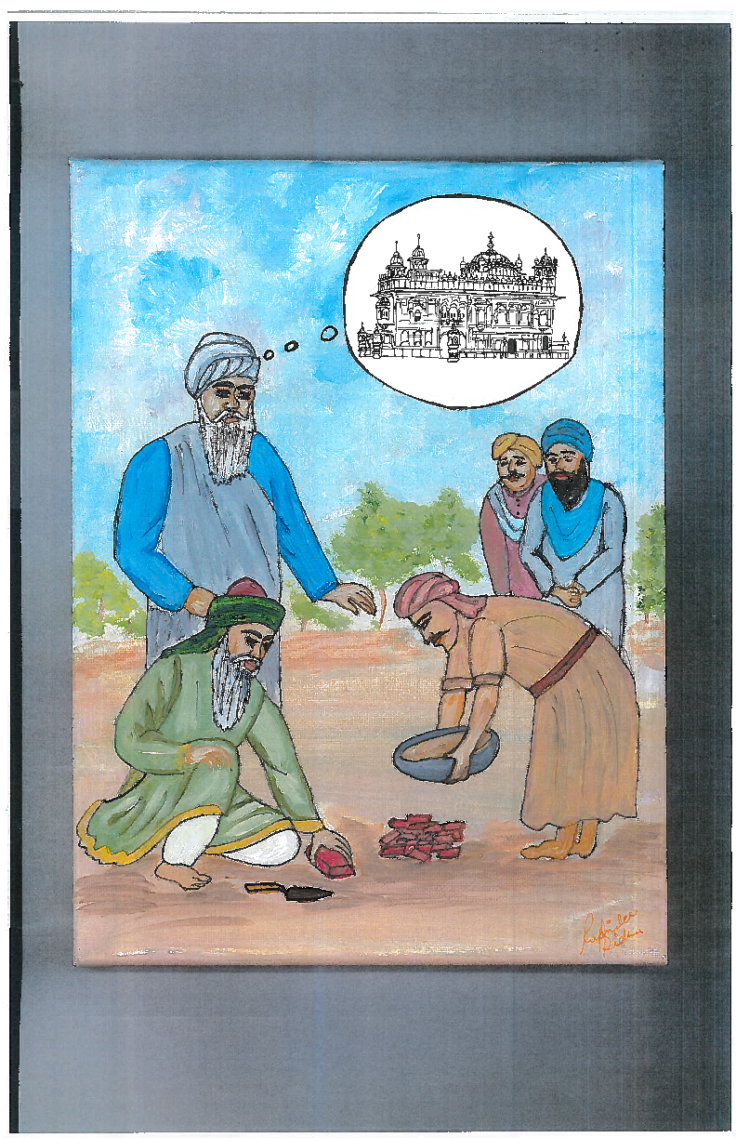
7. Marriage

1589 (age 26): Arjan Sahib ji was married to Mata Ganga ji on June 19, 1589. Mata ji was the daughter of Bhai Krishan Chand of village Mau, India. Arjan Sahib Ji arrived here the day before the wedding. The village is now famous for Arjan Sahib ji and Mata Ganga ji’s wedding. The place where they wed is now known as Gurdwara BILGA. Arjan Sahib ji’s chola (shirt), pyjama (trouser), Batva (purse), Dushala (Shawl), Simrana Mala (rosary) and Chandan ki chowki (stool made of sandalwood) are kept at this gurdwara.
Every year on the occasion of marriage of Arjan Sahib ji and Mata Ganga ji, a great fair is held here over three days. On the last day, the holy clothes of Guru Sahib are displayed before the closing ceremony of Diwan.

1590 (age 27): (Guru) Hargobind ji⁽⁵⁾, the only child of Sri Arjan Sahib ji was born on June 19, 1590.
______________________________________________________________________________________________________________________________
(5)- The story that Hargobind ji was born because of Baba Budha ji’s blessing is false. It is contrary to the Sikh principles. It also assumes that Guru Arjan Sahib ji was not capable of these powers. It is an imagination of someone who believes in Brahminic concepts of blessings and curses as manmade.

************************

8. Bhai Manjh

The real name of Bhai Manjh was Tiratha but he was better known by his last name - Manjh. A resident of Hoshiarpur, Bhai Manjh was a follower of Sakhi Sarwar (a religious sect). He constructed Pirkhanas (places for worship), in the nearby villages to propagate his faith.

Once Bhai Manjh set out to make a pilgrimage to Nigaha Pir. His friends and admirers also accompanied him. While returning home he met a Sikh who was reciting hymns of Guru Nanak Dev ji. He was impressed by the melodious hymns and expressed his desire to meet Guru ji. The Sikh said the current Guru, Arjan Sahib ji, the fifth Nanak was guiding the Sikhs and was residing in the city of Amritsar.

Bhai Manjh, wasting no time, took leave of his followers and friends and reached Amritsar. Guru ji was occupied with the construction of Sarovars. Bhai Manjh started performing sewa of collecting wood for the community kitchen (langar).

One day, while he was returning from the forest with a bundle of firewood on his head, there was a thunderstorm. It was so severe that one could barely find one’s way. Swept by the force of wind, Bhai Manjh fell into an abandoned well with shallow water. Whilst in the well, Bhai Manjh did not let the bundle of wood fall from his head so it should remain dry for use in Guru’s kitchen. Bhai Manjh stayed overnight in the well reciting the Guru's word all the time.

Luckily, a farmer of the area passing by noticed Bhai Manjh. He immediately informed the fifth Nanak. Guru ji took some volunteers with him and personally came to rescue Bhai Manjh. The Sikhs threw a rope towards Manjh and requested him to catch hold onto it and climb up. Bhai Manjh insisted to come out only after the bundle of wood had been pulled out.

Guru ji was very pleased with Bhai Manjh’s dedication and service. He appointed him as a preacher and advised him to return to his village to propagate Sikhi.

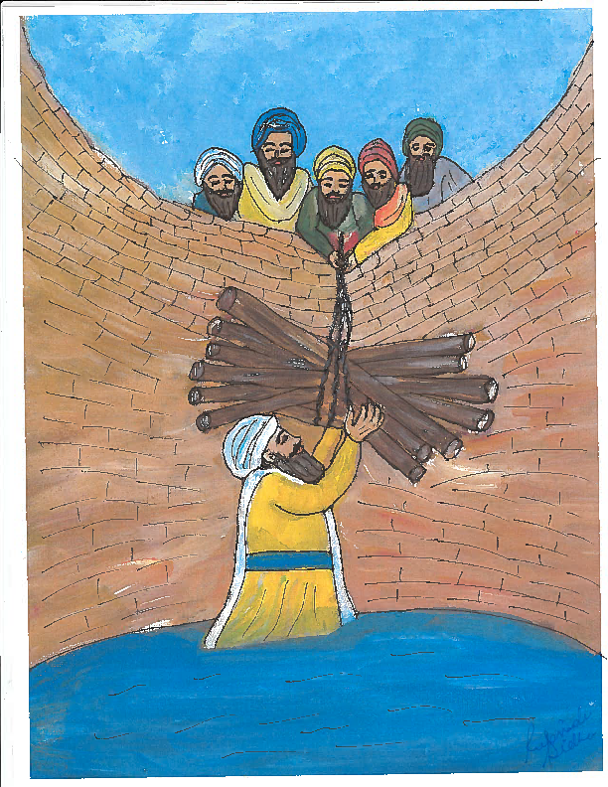

9. Merely Reading Holy Books does not Help
Once a Brahmin came from Benaras (a holy Hindu city) to meet the Fifth Nanak. He brought his young son with him. He also brought some religious books. He requested Guru ji for permission to read these books to the Sikhs. Guru ji readily agreed. He believed he would be able to influence Sikhs about the high ideals of Hindu religion. Secondly, he must have expected offerings from Sikhs and getting some financial help. The readings did not have the desired effects on Sikhs. The Brahmin thought of getting more books from Benaras in his quest to achieve his objective. He requested Guru ji to let him send his son to Benaras. Guru ji agreed.

Brahmin consulted his books to determine the auspicious time to dispatch his son. At the calculated time he prayed to gods and goddesses for their blessings. At the right time he took his son to the city border to see off. Unfortunately, a donkey made some sound on seeing the son. Brahmin took this as a bad omen. He returned with his son to wait for the right moment to leave. Sikhs asked the reason for coming back. When he explained, everyone laughed.

Guru ji asked him how a donkey by making sound can erase all the effort of reading holy books and praying to gods. Guru ji explained that simply reading holy books is of no use. One must understand and improve his/her conduct by following the message in the holy books.

Sikh religion emphasizes no such belief in good or bad omens is to be harbored and practiced in real life. Bhai Gurdas ji has a special Vaar on such common beliefs. These were Brahminic rituals to fool the masses for their own selfish purposes.

************************

10. Treat Diseases with Medicine
1598 - 1601 (age 35 - 38): Majha area of Punjab experienced severe famine during these years. As people did not get enough to eat, they became physically weak, fell sick and many died. Guru ji helped the weak in every possible way. He also helped in disposing off the dead bodies.
Deadly diseases like cholera and smallpox spread widely. Smallpox, particularly attacks children. Fifth Nanak’s son - Hargobind ji, who was only five years old, also fell a victim and contracted smallpox. The disease is life threatening and some lose their eyesight.
Due to prevalent beliefs illiterate people did not consider smallpox to be a disease. They believed it was an onset of a goddess (Mata). They indulged in singing the praises of the goddess lest it got angry and hurt the person.
Outside every village illiterate people constructed a small temple dedicated to the goddess of smallpox. When someone got sick with this disease, he/she was taken to this temple. Praises to the goddess were sung to please her and pray for a cure.
Though, Amritsar city was constructed by Sikh Gurus, everyone had the freedom to practice their own religion - Hindus & Muslims. Hindus had constructed a temple outside the city dedicated to smallpox goddess.
With full sincerity, well-wishers came to Guru ji suggesting him to take baby Hargobind to this specific temple so that he may get well. The fifth Nanak explained to everyone that linking the disease to the goddess is a myth. The disease must be treated with medicine. To treat disease was every householder’s responsibility. Guru ji composed and sang many hymns to educate Sikhs regarding this disease.
************************

11. Popularity of Sikh Gurus

1598 (age 35): Under the illuminating and guiding light of Gurus teachings, followers of Sikhi began to increase. The Gurus’ message of peace and harmony in such tragic times when the Mughals were inflicting barbarous acts on the masses rang a sympathetic chord with public. Both Hindus and Muslims were impressed with the Guru’s message. Large number of people started coming to the Guru's congregation in the newly constructed Harmandar Sahib. Guru Arjan Sahib Ji’s popularity irked and increased the orthodox Muslims’ hatred for Guru ji.

Many people embraced Sikhi, mainly from Hinduism but some as well from Islam. Due to the purity of the Guru's message and his enormous popularity, even Muslim pirs (saints) became followers of Guru Arjan Sahib Ji. Hindu saints, yogis and siddhas became followers and adherents of Sikhism. For the first time, the young Sikh religion became the prominent popular religion of Punjab.

Guru ji founded many villages, towns and cities and constructed numerous wells in Punjab. Peace and prosperity were once again returning to this region. Although the masses living in Punjab were happy with this development, the Mughal leaders in Delhi were upset.

In 1598, the Guru ji, on behalf of the local peasantry, requested Emperor Akbar to get the excessive land tax reduced. This initiative gave Guru ji a new status. Guru Arjan Sahib Ji came to be known as Sacha Patshah (True Emperor). Guru ji had come to guide, govern and influence the lives of the Sikhs both in the temporal and spiritual matters. Mughal Emperor Akbar had already been convinced of the reverence for the Sikh Gurus. During one of his campaigns he came to Goindwal and expressed a desire to meet with Guru ji. Akbar had to sit on the floor amongst men of other castes and take the simple food in the Langar. Only then he was able to meet with Guru Amardas ji.

A Muslim Pir, Saint Mian Mir of Lahore had great reverence for the Gurus. Opinion and words of the Pir were respected by Akbar. On one occasion, allegations against Guru Arjan by a few impostors (Prithi Chand and his son Meharban) and some jealous Brahmin priests were dropped based on Mian Mir’s recommendations.
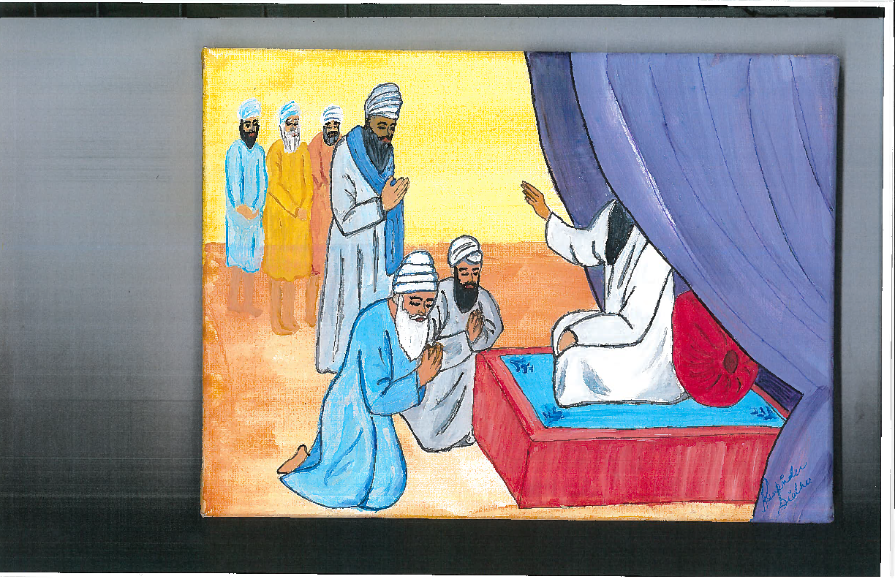

12. Adi Granth Sahib

1604 (age 41): Until then, each Guru ji’s Baani was separate though it was in musical modes (Raags). Guru Nanak Dev ji gave a great importance to music as it touches one’s heart and soul. He had composed all hymns in various Raags and sang them in Raags accompanied by Rabab (a string instrument). All successive Nanaks followed this tradition. Guru Nanak Dev ji kept a written record of the Words of God as and when these were revealed to him. This record is known as the Pothi (the Book). It explains the Ultimate Truth (nearness to God) and the way of realizing it. He had also collected the hymns of likeminded saints during his long journeys. The Pothi was always handed over to the next Nanak when the leadership of the faith was transferred to the successor. Guru Arjan Sahib received the Book when he became the Fifth Nanak.
Fifth Nanak gave due importance to music (Raag) and decided to compile hymns of all prior Nanaks and those of saints (Bhagats) according to Raags in one book. Under each Raag compositions were arranged chronologically by Nanaks - starting with first First Nanak, then second, third and so forth. Lastly, compositions of Bhagats were listed. Furthermore, within compositions of each Nanak, hymns were arranged as first the Shabads, then Ashtpadi (hymns having eight stanzas), Chhand (a style of Shabad) etc. As one can see, it was a time consuming and painstaking task. Bhai Gurdas ji was selected as the scribe. He was highly educated and a learned poet. The fourth Nanak had sent Bhai Gurdas on a mission to Agra and Benaras to spread Sikhism.

Ramsar Sarovar and Gurudwara, a quiet place outside the city of Amritsar was selected as the venue to undertake the task of compiling the holy book in a specific manner so that nobody could alter it. One reason for this was that in those days Prithi Chand and Meharban had compiled their own books in which they had written ballads in the praise of saints and prophets and started misleading the Sikhs. Teachings in Meharban’s book were not consistent with Sikh philosophy.

It is not clearly recorded in history as to how much time it took Bhai Gurdas ji to scribe the Adi Granth. It can be estimated that it could have taken one & a half year to complete the task. When the word of preparation of the Granth spread, many holy men came to Guru Arjan Sahib ji at Amrìtsar to get their hymns included in this Granth. Guru ji included only those hymns which were consistent with the high ideals of the True Word.

Compilation of the Holy Book is a very valuable achievement of Guru Arjan Sahib Ji. The Holy Book is presently known as Sri Guru Granth Sahib. Compilation has four characteristics.
- Preserve the original treasures. Editing made it impossible for anyone to alter it
- Nearly half of the Guru Granth Sahib consists of Guru Arjan Sahib ji’s own compositions.
- The Granth Sahib throws considerable light on the contemporary political and social life.
- Spiritual compositions of various saints e.g. Shaikh Farid, Bhagat Kabir, Bhagat Ravidas, Dhanna, Namdev, Ramanand, Jai Dev, Trilochan, Beni, Pipa and Surdas were included in the Granth Sahib. These saints belong to different times, beliefs, sects, and castes from high to low.

Compilation, the Granth Sahib⁽⁶⁾ was completed on July 31, 1604. It was formally enthroned in the Harmandar Sahib on August 30, 1604. Granth Sahib became the touchstone of the True Word. Baba Budha ji was appointed the first granthi (one who reads and interprets the Granth). _____________________________________________________________________________________________________________________________
(6) - It is universally accepted that the Baanii from Japji to Mundhawani were included in the Granth Sahib.
-There is no agreement on Raag Mala. It is a composition by poet Aaalam in the book ‘Madhav Nal Kaam Kandala’. Some believe it was inserted later while making a copy of the Granth Sahib.
-Also, a story that Guru Arjan Sahib ji went to Mohan (Guru Amardas ji’s son) to bring two books of Gurus’ Baani is also baseless. Guru Arjan ji received all the Baani when he became Fifth Nanak.
************************
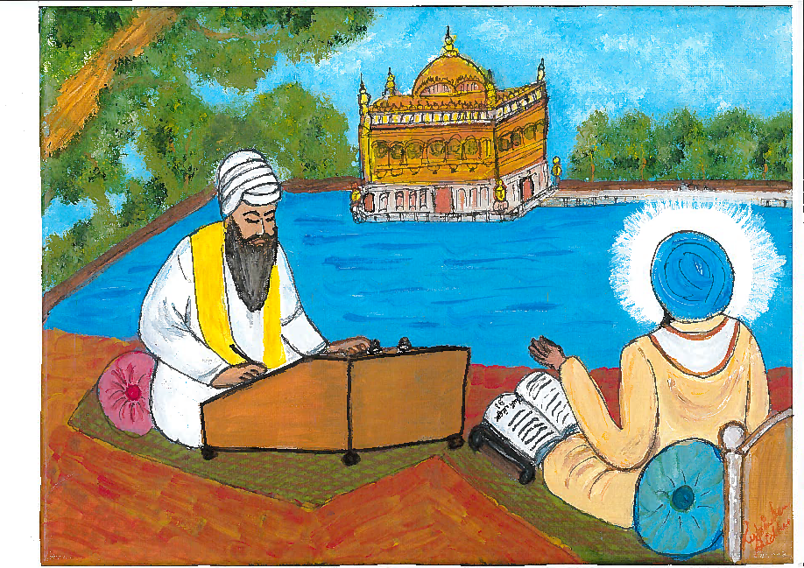

13. Jahangir Arrests Guru Arjan
1606 (age 43): The Sikh religion became very popular during Guru Arjan Sahib j and was growing rapidly. People from different religions/castes were becoming Sikhs. Even Muslims accepted Guru Arjan as their guide and religious teacher. Muslim priests (Qazis and Mullahs] did not like this. They wanted all non-Muslims to convert to Islam but quite the opposite was happening. Seeing Guru Arjan Sahib ji to be an impediment in their quest for spreading Islam, Muslim priests began to conspire against the Guru.

The first three Mughal emperors (Babur, Humayun and Akbar) were kind and just to people of every religion. They even made friends with Sikh Gurus. Akbar's son - Jahangir became the emperor in October 1605 at the age of 36. Jahangir’s policies and views were quite the opposite; he wanted to spread Islam.

Akbar was considering his grandson - Khusrau - to be the next emperor after him instead of Jahangir (his son). Jahangir promised Muslim priests that he would vigorously enforce Muslim law in exchange for their support to become next emperor. Once Jahangir became the emperor, Muslim priests conspired against Guru ji. They urged the new emperor to stop the spread of Sikhism. Muslim priests had been upset for a long time seeing that some Muslims were attracted to and were accepting Sikh religion. The only way to stop this was to put an end to Guru Arjan Sahib ji's life. The Emperor promised to act accordingly.

At this time, Jahangir's son - Khusrau - revolted against him. He wanted to become the emperor replacing his father. He waged a war against Jahangir but lost. He fled towards Lahore. Jahangir went after him to catch and punish him. He knew that many people had helped the prince to rebel against him. As he went along, Jahangir made enquiries to find out who had helped Khusrau. Jahagir punished as many of them as he could find. He passed by Goindwal and Tarn Taran. He made a halt at Goindwal. He made inquiries at Goindwal, too but no one said a word against Guru ji. If the Guru had helped Khusrau, they would certainly have said so to Jahangir. But The Guru had a number of enemies like Chandu, some Brahmins and Qazis who were looking for a reason to complain against the Guru. Prithia Chand, an arch enemy, had been deceased in late 1605.,

Jahangir reached Lahore and after a short stay, got ready to return to Delhi. The enemies of Guru Arjan decided to seize the opportunity to carry out their nefarious plans. They made up a false story against Guru ji. They met Jahangir and falsely explained that Khusrau had met Guru Arjan Sahib ji at Goindwal to seek his help. They alleged Guru ji had prayed for his success against Your Majesty and gave him a large sum of money.

Upon hearing such falsities, Jahangir became infuriated. He had already made up his mind to put an end to Guru Arjan Sahib Ji's life. He had promised Muslim priests to do so. He had found a good enough excuse to punish Guru ji. Jahangir did not make any inquiries to seek the truth. He had no intention to do so. The fact was, no such report had been made to him at Goindwal or at any other place.

On May 22, 1606, Jahangir instructed his men to go to Amritsar, arrest Guru ji, and bring him to Delhi. Guru ji was arrested on May 24th. He ordered Murtaza Khan to put Guru ji to death. He gave these orders and left for Sindh. The Fifth Nanak was very popular with the public because of his dedication to serve the needy (during three years of famine in Lahore, taking care of mass dead-bodies in Lahore, people suffering from cholera & smallpox etc), his humble and loving nature. Jahangir did not like to be seen personally torturing a person with mass appeal. Murtaza Khan also wanted to distance himself from this horrible crime. Chandu Lal (a Khatri Hindu), who had some personal animosity towards the Guru, volunteered to do the dirty job.

Before leaving Amritsar, the Fifth Nanak appointed his son - Hargobind Sahib as the Sixth Nanak in presence of Baba Budha ji, Bhai Gurdas ji and other prominent Sikhs.

************************

14. Martyrdom
1606 (age 43): Guru Arjan Sahib ji was brought to Lahore from Amritsar. Chandu took Guru ji to his residence in Lahore to carry out Jahangir’s orders. He began to secretly torture Guru ji so that public would not come to know about it.
On the first day, the Guru ji was not given anything to eat or drink. He was not allowed to sleep. He bore through all this very calmly. He kept meditating, chanting His Name, and reciting holy hymns.
The second day, Chandu made the Guru sit in a big copper vessel filled with water. He ordered his men to light a fire under the copper vessel to bring the water to boil. It scalded Guru’s body. But the Guru sat calmly and quietly. He did not cry, not even sighing. Guru Ji felt no anger against those who were torturing him. He continued to meditate on God’s Name. He prayed for strength to bear everything with calmness and courage. He went on repeating His Name, 'All is happening, O Lord, according to Thy Will. Thy Will is ever sweet to me.’ The boiling water made the Guru’s flesh soft and painful. Blisters appeared all over his body.

On the third day, Chandu made Guru ji sit on red hot iron plate and poured red-hot sand on his head and body. The persons engaged in torturing him were drenched with sweat because of the heat. It was June, the hottest month of the Indian summer. But the Guru kept calm and quiet. He uttered no cry. He felt no anger against those who tortured him. He only kept thinking of God repeating His Name. He kept reciting, ‘Thy Will is ever sweet to me, O Lord!

The horrific news could not stay hidden for long. Soon, the people came to know about it. But they had no power to influence the emperor. News reached Saint Mian Mir - a great Muslim saint of Lahore and a friend of the Guru. He was a pious person. He treated everyone with respect irrespective of his/her religion. He was greatly respected by all Muslims. Even Emperor Jahangir had great respect for him. On hearing what was happening to Guru ji, Mia Mir got angry and went to see Guru ji. Mian Mirs’ request to stop the torture fell on deaf ears. Chandu and his cohorts had already conceived of a suitable answer. They responded that since orders were given by the emperor himself, they could not dare disobey it.

On the fourth day, the Guru ji was made to sit on red hot iron plate. The Guru's flesh began to roast. Then burning red-hot sand was poured on his body. The Guru sat calm and quiet. He uttered no cry. He felt no anger against the torturers. He sat with his mind fixed on God. He kept repeating His Name. He kept repeating, 'Thy Will is ever sweet to me, 0 Lord!'
On the fifth day, the Guru was taken to the river Ravi and thrown into the running water. His body was too weak with all the tortures he had undergone to stand up against the fast-flowing water. His body got washed away. Guru ji became a martyr on May 30, 1606.
At the place where Guru Arjan Sahib ji merged with God, stands a beautiful gurdwara called Dera Sahib. Presently, it is in Pakistan. For Sikhs, it is a sacred place. Every year, a big gathering, called Jor Mela, was held there on the day on which the Guru left for his Eternal Abode. Sikhs used to visit it in large numbers every day.
______________________________________________________________________________________________________________________________
Note: Some innocent sikhs serve sweetened cold water (Chabeel) at this occasion hoping it will provide comfort to Guru ji in heaven. This thinking is contrary to Sikhi principles. There is no connection of Chabeel with this Gurpurb. Otherwise, there is no objection to serving cold water to needy during hot weather.

************************

15. Highlights of The Fifth Nanak
{1563 - 1606}
Born on: April 15, 1563.
Born at: Goindwal, Amritsar
- Father – Guru Ramdas
- Mother – Mata Bhani
- Guru’s wife - Mata Ganga ji
- Son - Hargobind

Accession to Guru gaddi: September 1, 1581 at Goindwal.
Bani: Total number of hymns 2218 in 30 Ragas, e.g. Sri Rag, Asa, Basant, Majh, Gujari, Gauri and Suhi etc.
His Message: In his Sukhmani, recited in Rag Gauri during the years 1601-1604; he describes the essence of true life, the union of Soul with the Supreme Being and great significance of the Guru and the saintly people in one’s life.
Special Contribution: Compiled the Granth Sahib in the year 1604; now revered as The Guru Granth Sahib by the Sikhs.
- Enjoined the Sikhs to contribute one tenth of their righteous earnings, called Dasvandh, for community purposes. This measure was undertaken to strengthen the Sikh Movement, economically.
- Was the first martyr who laid the foundation of great Sikh tradition of Martyrdom.
Cities Founded and Construction Work: Completed the construction of Santokh Sar in 1588.
- Started the construction of Harmandar Sahib in 1588.
- Started the work of digging of a tank at a place, now known as Taran Taran Sahib in the year 1590.
- Founded a city named Kartarpur in Dist. Jalandhar in 1594 and
Sri Hargobindpur on the banks of river Bias.
Succession to Guru gaddi: Guru Sahib nominated his son, Hargobind as the sixth Guru of the Sikhs.
Joti-Jot Samaye: May 30, 1606 at Lahore, Pakistan.
16. World Events 1563-1607

- 1563 - Francisco de Ibarra explores New Mexico, USA
- 1564 - Peace treaty of Troy between England and France
- 1564 - William Shakespeare was born
- 1568 - Alliance between England and Netherlands
- 1589 - Sir Walter Raleigh established Virginia Colony, USA
- 1600 - Queen Elizabeth I grant Charter to East India Company
- 1605 - Gunpowder Plot to blow out England’s parliament and James I
- 1607 - Captain John Smith explorer and founder of Jamestown, USA

17. References:
- Bed Time Stories 6, Santokh Singh Jagdev, Sikh Missionary Resource Center, England.
- Stories from Sikh History 3, Kartar Singh et al, Hemkunt Press, New Delhi, India.
- Gur Itihas (Patshahi 2-9), Prof Sahib Singh, Singh Brothers, Amritsar.
- Sikh Tvareekh (Part one 1469-1708), Dr. Harjinder Singh Dilgeer, Distributors - Singh Brothers, Amritsar.
- SGPC website, Ten Gurus
- Google search, world events.

